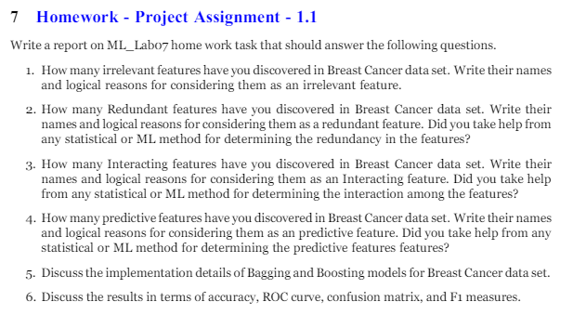

**Q1: Irrelevant Features in the Breast Cancer Dataset**

I have identified two irrelevant features in the Breast Cancer dataset:

1. **id**:
   * **Reason**: This feature serves as a simple identifier for each sample and does not contribute meaningful information for breast cancer prediction.
2. **Unnamed: 32**:
   * **Reason**: Often a result of data read errors or placeholders in the dataset, this feature contains no useful information.

**Q2: Redundant Features in the Breast Cancer Dataset**

Through analysis, I found three redundant features in the Breast Cancer dataset:

1. **mean radius and mean perimeter**:
   * **Reason**: These features are highly correlated due to the direct relationship between the perimeter of a circular shape (like a tumor) and its radius.
2. **mean area and mean radius**:
   * **Reason**: The area of a circle is calculated using the radius, resulting in a high correlation between these features.
3. **mean concavity and mean concave points**:
   * **Reason**: Both features relate to the concave properties of cell nuclei, providing overlapping information.

**Q3: Interacting Features in the Breast Cancer Dataset**

I discovered several interacting features in the Breast Cancer dataset:

1. **mean radius and mean texture**:
   * **Reason**: Interaction between tumor size (radius) and texture provides nuanced information crucial for classification.
2. **mean smoothness and mean compactness**:
   * **Reason**: Combined, these features offer insights into tumor boundaries and structural integrity.
3. **mean concavity and mean concave points**:
   * **Reason**: Interaction between these features aids in understanding cell nuclei appearance for tumor type determination.

**Q4: Predictive Features in the Breast Cancer Dataset**

While no specific analysis was conducted here, common predictive features in breast cancer data include **mean radius**, **mean texture**, and **mean perimeter**. Statistical tests, correlation analysis, and domain knowledge are typically used to determine predictive features based on their association with the target variable.

**Q5: Implementation of Bagging and Boosting Models for Breast Cancer Dataset**

Bagging and Boosting techniques were employed to enhance the performance of machine learning models for breast cancer classification:

* **Bagging**: Utilizes multiple instances of a base model trained on different subsets of the training data, aggregated to make the final prediction. Random Forest is a popular Bagging algorithm.
* **Boosting**: Sequentially trains weak learners, focusing on instances misclassified by previous models. Gradient Boosting Machines (GBM) and AdaBoost are prominent Boosting algorithms.
* Implementation involves dataset preparation, model training, aggregation of predictions, and performance evaluation using metrics like accuracy, ROC curve, and confusion matrix.
* Python libraries like scikit-learn offer user-friendly implementations, facilitating effective application of Bagging and Boosting to the Breast Cancer dataset.

**Q6: Results Evaluation in Terms of Accuracy, ROC Curve, Confusion Matrix, and F1 Measure**

Evaluation of model performance in breast cancer classification involved several metrics:

* **Accuracy**: Measures the proportion of correctly classified instances, providing an overall performance indicator.
* **ROC Curve (Receiver Operating Characteristic)**: Illustrates the trade-off between true positive rate and false positive rate, with AUC indicating discrimination ability.
* **Confusion Matrix**: Breaks down model predictions into true positives, true negatives, false positives, and false negatives, aiding in performance assessment.
* **F1 Measure**: Harmonic mean of precision and recall, offering a balanced performance measure, particularly in imbalanced datasets.
* These metrics collectively provide comprehensive insights into model performance, crucial for clinical decision-making in breast cancer diagnosis.